

MOI GIRLS’ ELDORET 2025 PREDICTION
POSSIBLE KCSE EXAM
CHEMISTRY
233/2
PAPER 2
TIME: 2 HOURS

NAME……………………………………………………………………………………….
SCHOOL……………………………………………… SIGN………………………..
INDEX NO……………………………………………. ADM NO……………………

Kenya Certificate of Secondary Education (KCSE)

INSTRUCTIONS
- Write your name and index number in the space provided
- Sign and write the date of examination in the space provided above
- Answer all questions in the space provided after each question
- Mathematical tables and electronic calculators may be used
- All working must be clearly shown where necessary

FOR EXAMINERS ONLY
QUESTIONS | CANDIDATE’S SCORE

Answer all questions in the space provided
- The grid below forms part of the periodic table. Study it and answer the questions that follow. The letters do not represent the actual symbols of the elements.

P

Q
R

S

T
U

V

W
X

Y

Z

M

- Write the general name given to the elements to which Y and Z belong. (1mk)
…………………………………………………………………………………………………………
…………………………………………………………………………………………………………

- An element N has an atomic number of 15. Write down its electronic arrangement and hence fix it in its right position on the grid above. (2mks)
Electronic arrangement____________________________

- Compare the size of the atom of R and that of its ion. Explain your answer. (2mks)
…………………………………………………………………………………………………………
…………………………………………………………………………………………………………
…………………………………………………………………………………………………………

- Give the formula of the compound formed between
- P and W ____________________________________ ½ mk
- T and Y ____________________________________ ½ mk

- Compare the melting points of element Q and S. Explain (2mks)
…………………………………………………………………………………………………………
…………………………………………………………………………………………………………
…………………………………………………………………………………………………………
…………………………………………………………………………………………………………

- State the least reactive element in the grid. Give a reason for your answer (2mks)
Element________________________________________
Reason ______________________________________________________________________

- Give two advantages that element S has over element Q in making electric cables (2mks)
…………………………………………………………………………………………………………
…………………………………………………………………………………………………………
…………………………………………………………………………………………………………

- Draw (a) dot (.) and cross (x) diagram to represent the bonding in compound formed between T and Y (2mks)

- Study the condensed formulae below and answer the questions that follow
(a) I CH₃CH (CH₃) CH₂CHCH₂
II CH₃CH₂CH (OH) CH₂OH
- Draw the structural formula of each of the compounds I and II (2mks)
- .

- Give the systematic name of each of the compounds represented by the formulae above (2mks)
I____________________________________________
II____________________________________________

- To which homologous series does the compound represented by I belong (1mk)
…………………………………………………………………………………………………………

(b) The flow chart below shows some reactions starting with a long chain alkane. Study it and answer the questions that follows.
- Name substance (3mks)
A___________________________
B___________________________
C____________________________

- What is the name given to the process represented by
Step I_______________________ ½ mk
Step III______________________ ½ mk
Step IV______________________ ½ mk
Step VI______________________ ½ mk

- Write down the chemical equation represented by the reaction in step VI (1mk)
…………………………………………………………………………………………………………
…………………………………………………………………………………………………………

- (a) The following table shows the standard reduction potentials for four half cells. Study it and answer the questions that follow. The letters do not represent the actual symbols of the elements
E θ volts
$$W_{2(g)}+2e− →{2W−}_{(aq)}+0.54$$
$$X_{(aq)}^{2+}+2e− →X_{\left(s\right)} −0.44$$
$$Y^{2+} +2e− → Y_{\left(s\right)} +0.34$$
2Z (aq) + 2e- Z_{2 (g)} Z_{2(g)}0.00

- Explain why the Z half- cell has 0.00 voltage (1mk)
…………………………………………………………………………………………………………
…………………………………………………………………………………………………………

- Identify the strongest reducing agent (1mk)
…………………………………………………………………………………………………………

- Write the equation for the reaction which takes place when solid X is added to the solution containing Y²⁺ ions (1mk)
…………………………………………………………………………………………………………
…………………………………………………………………………………………………………

- Which two half-cells above would provide the highest voltage if connected? (1mk)
…………………………………………………………………………………………………………
…………………………………………………………………………………………………………
…………………………………………………………………………………………………………

- Calculate the voltage generated by the half-cell you have mentioned in (IV) above (2mks)

(b) The following diagram shows the electrolysis of water that is slightly acidic study it and answer
the questions that follows.
- Identify (1mk)
Electrode K …………………………………………………………………………………
- Why was it necessary to acidify the water? (1mk)
…………………………………………………………………………………………………………
…………………………………………………………………………………………………………

- Explain why the water could not be acidified using hydrochloric acid if the desired products were oxygen and hydrogen (1mk)
…………………………………………………………………………………………………………
…………………………………………………………………………………………………………

- During the electrolysis of aqueous copper (II) sulphate 48,250 coulombs of electricity were used. Calculate the mass of copper that was deposited at the cathode (2mks)
(IF=96500columbs Cu=63.5)

- The diagram below represent two industrial processes; one leading to the manufacture of ammonia and the second leading to the manufacture of Nitric acid. Study it and answer the questions that follow.
Nitrogen

Step I Step II
Nitrogen (II) Oxide
Ammonia
Excess air
Hydrogen

A Step III
Nitrogen (IV) oxide
Nitric (V) acid

Purified air

- Describe one large scale source of
- Nitrogen (1mk)
…………………………………………………………………………………………………………
…………………………………………………………………………………………………………
- Hydrogen (1mk)
…………………………………………………………………………………………………………
…………………………………………………………………………………………………………

- Name the catalyst required in
- Step II______________________________

- Write the chemical equation for the reaction that takes place between ammonia and oxygen in the presence of the catalyst you have named in b (i) above (1mk)
…………………………………………………………………………………………………………
…………………………………………………………………………………………………………

- Ammonia reacts with nitric acid to form substance P.
- write the chemical equation for the formation of substance P (1mk)
…………………………………………………………………………………………………………
…………………………………………………………………………………………………………

- Give one possible use of substance P (1mk)
…………………………………………………………………………………………………………
…………………………………………………………………………………………………………

- Give the general name given to the process represented by Step I (1mk)
…………………………………………………………………………………………………………

- Nitrogen and hydrogen reacts according to the following equation at 450°c and 200 atmospheres
N_{2 (g)} + 3H_{2 (g)} $⇌$ 2NH_{3 (g)} $⊿H=−92kJ$
- State and explain how the yield of ammonia would be affected if the pressure is reduced (2mks)
…………………………………………………………………………………………………………
…………………………………………………………………………………………………………
…………………………………………………………………………………………………………

- Name one use of nitric acid apart from making substance P named in (c) above (1mk)
…………………………………………………………………………………………………………
…………………………………………………………………………………………………………

- Name substance A and write an equation to show how it reacts with nitrogen (IV) oxide to form nitric (V) acid
Substance A______________________________________________
Equation …………………………………………………………………………………………………………
…………………………………………………………………………………………………………

- (a) Draw a diagram in the space provided below to show how the heat of combustion of ethanol can be measured experimentally (3mks)

(b) In an experiment to measure the heat of combustion of ethanol the following data was collected.
Volume of water 450cm³
Initial temperature of water 25°c
Final temperature of water 46.5°c
Mass of ethanol + lamp before heating 125.5g
Mass of ethanol + lamp after heating 124.0g
- calculate:
- Heat evolved during the experiment (Density of water =1g/cm³. Specific heat capacity of water =4.2KJ Kg⁻¹K⁻¹) (2mks)

- Molar heat of combustion of ethanol (C=12, O=16, H=1) (2mks)

- The molar heat of combustion obtained from an experiment like the one above is usually lower than the theoretical value. Explain (2mks)
…………………………………………………………………………………………………………
…………………………………………………………………………………………………………
…………………………………………………………………………………………………………
…………………………………………………………………………………………………………

(c) The molar heat of combustion of hydrogen is given as -286KJmol⁻¹
- Write the thermochemical equation for the reaction above (1 ½ mk)
…………………………………………………………………………………………………………
…………………………………………………………………………………………………………
…………………………………………………………………………………………………………
…………………………………………………………………………………………………………

- Draw an energy level diagram for the reaction in c(i) above (2mks)

d) (i) What is a fuel? (1mk)
…………………………………………………………………………………………………………
…………………………………………………………………………………………………………
…………………………………………………………………………………………………………
(ii) Name one environmental effect of using carbon and some of its compounds as fuels( ½mk)
…………………………………………………………………………………………………………
…………………………………………………………………………………………………………

- (a)
Mixture M

Step I (i) Addition of water
(ii) Filtration
White precipitate Q
Solid N
Add Ba²⁺/H⁺
Solution P

Step II Heat
Add NaOH until in excess Add ammonia solution until in excess
Red brown solid when hot yellow when cold . Gas that forms white precipitate with calcium hydroxide given off
White precipitate which dissolves in excess
White precipitate which dissolves in excess

The diagram above shows some reactions starting with mixture M. Study it and answer the questions that follow.
- Name the possible identity of
Solid N_____________________________________ (1mk)
Solid P_______________________________________(1mk)
- Write the formula of the identity of white precipitate Q
………………………………………………………………………………..

- Describe the test that can be carried out to test for the presence of the cation in solid N and give the possible observations if the test is positive. Fill this information in the table below.
Test | Observation
1.  (1mk) | (1mk)
2.  (1mk) | (1mk)

(b) Starting with Copper (II) Oxide, explain a step by step method that can be used to prepare crystals of copper (II) sulphate (3mks)
…………………………………………………………………………………………………………
…………………………………………………………………………………………………………
…………………………………………………………………………………………………………
…………………………………………………………………………………………………………
…………………………………………………………………………………………………………

- The diagram below shows a blast furnace that is used in the extraction of iron
Q
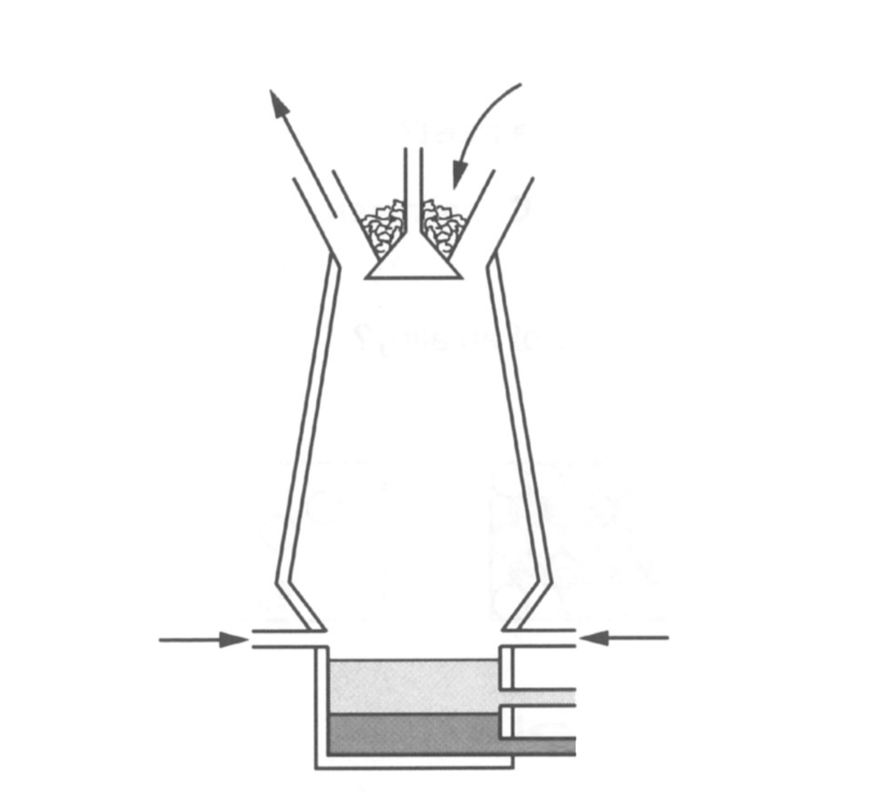
P

- State the composition of mixture P (2mk)
…………………………………………………………………………………………………………
…………………………………………………………………………………………………………

- Write down the use of the following in the process above.
- Limestone (1mk)
…………………………………………………………………………………………………………

- Coke (1mk)
…………………………………………………………………………………………………………

- Name substance Q and write chemical equations to show how it is formed
Name ____________________________________________ (1mk)
Chemical equations (2mks)
…………………………………………………………………………………………………………
…………………………………………………………………………………………………………

- Write down a chemical equation to show how iron is formed in the above set-up. (1mk)
…………………………………………………………………………………………………………
…………………………………………………………………………………………………………

- Name one use of iron (1mk)
…………………………………………………………………………………………………………
…………………………………………………………………………………………………………

